United Nations Population Fund
Asia and the Pacific Regional Office in Bangkok
12^{tth} Floor, United Nations Building
Rajdamnern Nok Avenue, Bangkok 10200
Tel. (66-2) 687 0107
Fax (66-2) 282 1550

INVITATION TO BID – SALE OF SURPLUS ASSET

Date: 11 August 2016
Reference No: UNFPA/APRO/ASSET/DISPOSE/16/02
Bid submission deadline: The deadline is extended from Thursday, 1 September 2016 at 15:00 hours, Bangkok time to Thursday, 22 September 2015 at 15:00 hours.

Dear Sir/Madam,

The United Nations Population Fund, Asia and the Pacific Regional Office in Bangkok (UNFPA APRO), intend to sell the following office vehicle:

Make: Volvo S.80 2.5 FTS
Body Type: 4 Doors, Sedan
Registration date: 02 December 2009
Engine No.: B5254T11 4397276
Chassis No.: YV1AS0550A1116586
Capacity: 5 cylinders, 2521 CC
Colour: Ice White
Engine: Bioetanol/Petrol
Asset ID: 000000000363

- The sealed envelope should be clearly marked “BID ON SURPLUS UNFPA APRO ASSET” and dropped in the BID BOX specifically placed for this purpose in front of the meeting room of UNFPA APRO Office, 12th Floor, Block B, UN Secretariat Building, Rajdamnern Nok Avenue, Bangkok.

- UNFPA APRO expects the price range from THB 255,000 to THB 520,000 and the vehicle will be sold to the bidder who offers the highest price.

- Bid Form is strictly accepted only at UNFPA APRO Office no later than Thursday, 22 September 2016 at 15:00 hrs. Bangkok time.

- Bidders are urged to inspect the car prior to submitting bids. The car is located at the UN Building, Rajdamnern Nok Ave, Bangkok. It is offered for sale “AS IS, WHERE IS” and without recourse or warranties of any kind. The vehicle may be inspected between 10.00-15.00 hrs on UN working days. For inspection, please contact Mr. Mek Junjumrern at 02 687 0127 or 081 899 9373.

- UNFPA APRO reserves the right to reject any or all the bids submitted without assigning any reason. This invitation to bid does not commit UNFPA APRO to award a contractual instrument or to pay any costs incurred in, or in connection with, the preparation or submission of bids.

- Vehicle will be sold against best bid. Bids will be opened on 23 September 2016, 15:30 hrs at UNFPA APRO Office, 12th Floor, Block B, UN Secretariat Building, Rajdamnern Nok Avenue, Bangkok.

- Upon notification, the successful bidder must pay within five (5) working days the purchase price in full by cashier cheque in the name of “UNDP Representative in Thailand (THB) account”. Should the successful bidder fail to arrange payment within five (5) working days, the vehicle will be offered to the second highest bidder.

- Upon payment of the purchase price in full, title to the item passes to the successful bidder, all handling thereafter shall be at the expense and risk of the successful bidder.

- Transfer of title process is taking between 15-30 days after UNFPA APRO receiving of full sale amount. The successful bidder can take the vehicle from UNFPA APRO only after the Ministry of Foreign Affairs has approved of the car transfer.

- The successful bidder agrees to remove the vehicle at this/her expense and without damage to surrounding property, including building, and further offers and agrees to reimburse UNFPA APRO for any damage sustained as a result of his/her removal of the item (s) purchased.

- UNFPA APRO will not provide any assistance either mechanical or manpower for the removal of the item.

- The successful bidder is solely responsible for payment of any taxes, duties and fees of any kind which may be due as a result of this sale.

- International staff members are always excluded from bidding.

Annex I: Bid Submission Form

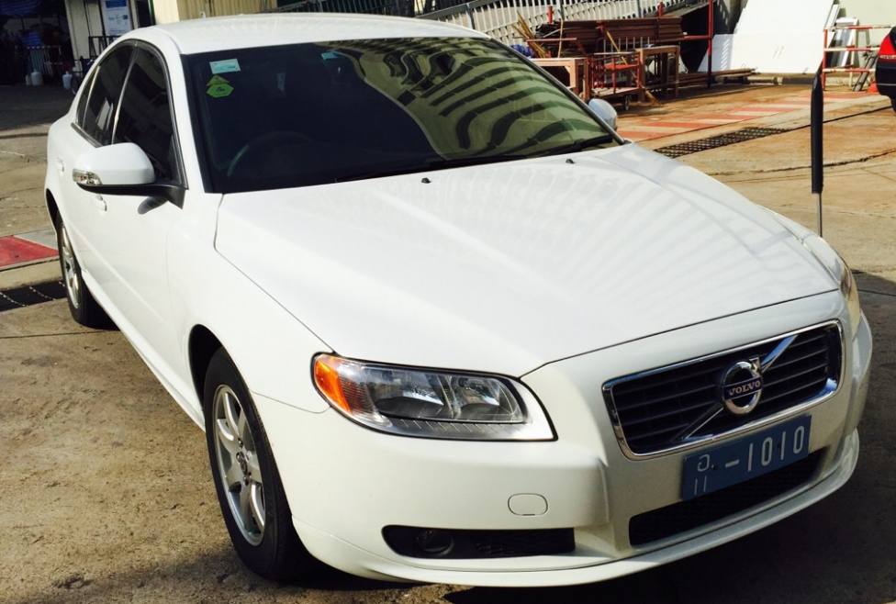

United Nations Population Fund
Asia and the Pacific Regional Office in Bangkok
12^{tth} Floor, United Nations Building
Rajdamnern Avenue, Bangkok 10200
Tel. (66-2) 687 0107
Fax (66-2) 282 1550
BID FORM

Disposal of office vehicle:

Make: Volvo S.80 2.5 FTS
Body Type: 4 Doors, Sedan
Registration date: 02 December 2009
Engine No.: B5254T11 4397276
Chassis No.: YV1AS0550A1116586
Capacity: 5 cylinders, 2521 CC
Color: Ice White
Engine: Bioetanol/Petrol
Asset ID: 000000000363

Please carefully read the terms and bid conditions as given on the Invitation to Bid no. : UNFPA/APRO/ASSET/DISPOSE/16/02.
กรุณาอ่านเงื่อนไขการยื่นซองประมูล ที่ระบุไว้ตามประกาศยื่นซองประมูลข้างต้น

I hereby acknowledge and accept the terms and conditions as stated.
ข้าพเจ้าเข้าใจและยอมรับเงื่อนไขที่ระบุไว้ตามประกาศการยื่นซองประมูลข้างต้น

Amount of bid offered (Baht)  ราคาประมูล |  |  | …………………………..………….
Bidder name  ชื่อผู้ประมูล |  |  | ……………………………..……….
Address  ที่อยู่ |  |  | …………………..………………….
 |  |  | ……………………..………………..
Telephone  โทรศัพท์ |  |  | ………………………..……………..
Signature  ลายเซนต์ |  |  | ………………………..……………..
Date  วันที่ |  |  | ………………………..……………..

